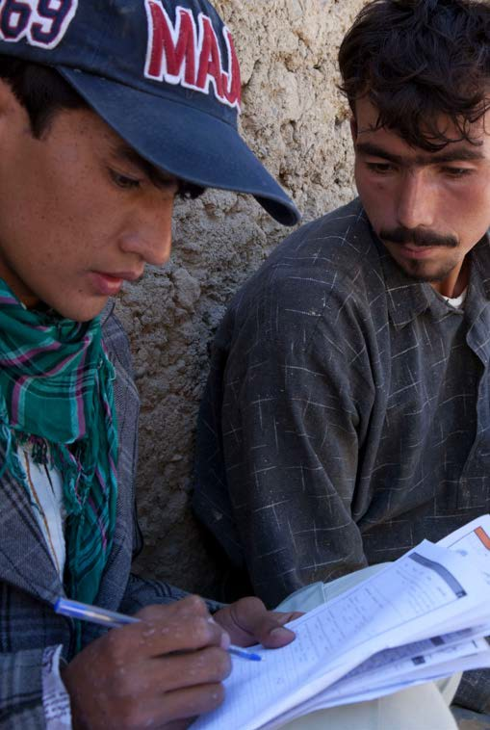

Technical Brief on the Implications of COVID-19 on Census
© UNFPA Afghanistan/ Lorenzo Tugnoli
—
Update No. 1, March 25, 2020

A sample of countries already 4
altering census plans in light of COVID-19
Key Recommendations and Resources 6
Sustaining UNFPA Census Capacity Strengthening 7
in the Face of Travel Constraints
Advocacy is Critical 8
Potential long-term Financial Constraints 9
Operational Choices for Census 9
Risks Associated with the Interruption 11
and Delay of Census Stages
Summary of Considerations 12
and Recommendations

As the world grapples with the spread of COVID-19, UNFPA must ad- dress the implications of the outbreak on preparations and implementa- tion of the 2020 census round. With 150 countries (including 85 UNFPA
programme countries) scheduled to conduct census enumeration in 2020 and 2021, the potential disruption of the 2020 census round could be significant. The COVID-19 pandemic will threaten the successful conduct of censuses in many countries through delays, interruptions that compro- mise quality, or complete cancellation of census projects. Domestic and donor financing for census may be diverted to address COVID-19 leaving census without crucial funds. Several countries have already taken deci- sions to postpone the census, with many others yet to announce the way forward.

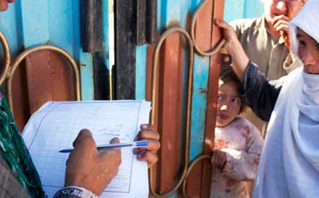
© UNFPA Afghanistan / Lorenzo Tugnoli

A sample of countries already altering census plans in light of COVID-19

Belize has postponed its census to 2021 in order to divert census funding for national emergency funding.

Brazil decided to postpone its census until 2021.

China still plans to undertake its census in November 2020, but preparations have been affected and are being reviewed.

Côte d’Ivoire’s census, planned for April 2020, may be delayed, given government containment and restrictions on internal travel. Tablets from China were delayed beyond the expected delivery in January, but recent news indicated they are now being shipped.

Ecuador is currently in its pre-census stage, conducting cartog- raphy data in large cities. Ecuador has interrupted all census ac- tivities now for 2 weeks, with expectations that this delay may be extended to 4 weeks. With the census enumeration scheduled for November 2020, delays in mapping could disrupt the timeline.

Kyrgyzstan decided to postpone its census scheduled for March 2020 by one month, with further delays possible.

Indonesia is preparing to extend the online time for self-enumer- ation, and cancel all field data collection. They will rely on admin- istrative data and have requested additional UNFPA technical sup- port for using administrative data for census.

Mexico is currently continuing its field data collection.

Panama’s census has been postponed by one year but they are currently assessing additional implications. They are evaluating the preparatory processes that can begin now, such as procurement.

In the United States of America, most residents received invita- tions to fill out the 2020 census in the second week of March. The US Census Bureau has postponed its community outreach program from late March to early April, as it includes in-person assistance to those unable to submit responses online.

The Seychelles census has now been postponed by one year, from August 2020 to August 2021. Field mapping, questionnaire de- sign, and pretest of data collection tools using tablets, are all pro- ceeding.

Key Recommendations and Resources
Middle Length Book Title

UNFPA Country Offices should support governments with contin- gency planning, continue to provide sound technical guidance and census capacity strengthening, and advocate for the importance of census for development, and for pandemic preparedness and response.

- A global effort must be made to assure that even where census is delayed, census planning and preparations are not cancelled, but continue apace in order to assure that imple- mentation can proceed safely when the pandemic is under control.

- To assure this, in-person census capacity strengthening that was planned by Headquarters and Regional Offices in Quarter 1 and Quarter 2 will be re-deployed for virtual deliv- ery. Please find links to available census planning and techni- cal guidance resources here, and anticipate invitations shortly to census technical webinars for your staff and NSO collabo- rators.

- While new census methods, including online, register- based, and hybrid approaches are being used across the world, these demand extensive planning and preconditions that cannot be created at short notice. Hence, Country Of- fices should discourage National Statistical Offices (NSOs) from shifting to new census approaches that have not been planned well in advance. A simple postponement of the planned census approach is most prudent.

- Advocacy will be critical in a moment when governments face many simultaneous challenges. UNFPA Country Of- fices are encouraged to emphasize the importance of census (see useful brochure here), including for preparedness and

response to the pandemic. UNFPA should support NSOs to assure that governments recognize the health and devel- opment urgency of fulfilling their statutory requirement to deliver in the 2020 census round.

- While the UNFPA Procurement Office (PSB) has recently provided news that IT supplies from China are now moving again, note that deliveries and receipts will remain affected as countries all over the world are putting in place containment measures that will affect shipments.

- The continuing low supply of protective equipment has immediate implications for conducting census in communities at risk of transmission. PSB is partnering with other agencies to explore new supply chains and resources.

Sustaining UNFPA Census Capacity Strengthen- ing in the Face of Travel Constraints

UNFPA Headquarters, Regional and Country Office Population & Development staff are rapidly planning alternative modalities for sharing technical assistance on census preparation and implemen- tation through teleconferencing, webinars and other online plat- forms.

In this regard, the UNFPA Census Refresher Workshops planned for Quarter 1 in Dakar, and Quarter 2 in Latin America, are currently being re-developed for virtual delivery, and can be expected for virtual global roll-out in Quarter2. Headquarters and Regional Of- fices have made no plans as of yet regarding potential face-to-face Workshops later in 2020.

Sustaining census capacity-strengthening virtually is paramount to maintaining and building census expertise, sustaining census preparations, and sharing examples of how to use census data for development and humanitarian action, including pandemic pre- paredness and response.

Advocacy is Critical
3 Paragraph title
Middle Length Book Title
This is an important moment for UNFPA to underscore the impor- tance of accurate population data not only for development, but also for addressing global health emergencies, such as COVID-19. While UNFPA routinely emphasizes the criticality of population data for humanitarian preparedness and response, these data are no less critical in the face of a pandemic. For example, govern- ments need up-to-date knowledge of population densities in ma- jor cities, as these are locations of higher transmission; the elevat- ed case fatality rates among older populations demand knowledge of where older people are clustered; the provision of emergency medical facilities requires data on catchment area populations; and even basic metrics on COVID-19 case-loads require accurate pop- ulation denominators by location.

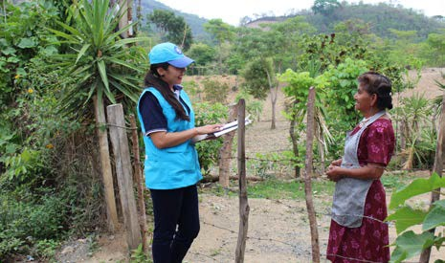

Potential long-term Financial Constraints
Governments are now prioritizing national resources for the public health response and economic consequences of COVID-19 and this diversion of resources has already contributed to the post- ponement of censuses in Belize, Brazil, and Seychelles.

If the economic consequences of the pandemic worsen, the likeli- hood of budget shortfalls for census operations will increase. The current instability of currency exchanges, and potential for global recession suggest that the economic impact of COVID-19 could be sustained, and substantial. Ultimately, this will increase the need to mobilize global financial support for censuses, and for population data in general.

Fund-raising for census at Country Office level should continue, and Headquarters and Regional Offices will offer as much support as possible in this regard. Fundraising efforts through the new UNFPA Population Data Thematic Fund will continue, and seek to supplement global resources available for census.

Most critical is advocating strongly for the need to postpone, and not cancel, censuses worldwide, highlighting the importance of population data for development needs that may increase due to COVID-19, and for preparedness and response to the pandemic.

Operational Choices for Census
Some Country Offices are asking whether UNFPA should advise governments to consider alternate approaches to census, such as registry-based census or e-census. Several have asked whether “hy- brid” model-based population estimates are a reasonable alterna- tive if COVID-19 prevents census-taking. UNFPA does not recom- mend changing census modality for any census that is already in an advanced stage of preparation. Country Offices should discourage NSOs from shifting to new census approaches that have not been planned well in advance. A simple postpone- ment of the planned census approach is most prudent. Infor- mation on different census modalities is provided below:

Use of Mixed Methods: Compared to the 2010 census round, the 2020 round already counts with a wider adoption of mixed meth- ods for census, including combinations of traditional and internet- based data collection, and registry-based census. However, regis- try-based census and online methods demand extensive planning and pre-existing conditions that may not be in place, particularly in low and middle income countries.
3 Paragraph title

Online Census: Use of online census requires high internet pen- etration, widespread computer literacy, public acceptance of the internet for official business, legal authority, and the availability of a national address or building register. Most importantly, most online census covers only a proportion of the population, and can there- fore only be complementary to door-to-door activities. For exam- ple, Iran’s first online census in 2016 covered an impressive 48% of the population, but the remaining population required face-to-face interviews. Even if 60% or 70% of a population could be counted online, this would still constitute a serious undercount of the popu- lation. Lastly, those uncounted in an online census are typically the most economically vulnerable or furthest behind, and it has to be the aspiration of every census to under no circumstances not leave these groups uncounted.

Use of Registry Data for Census: Some countries have well de- veloped administrative registers that can be used for a register- based census. However, it should be noted that the majority of countries that use administrative registers for census will still need to complement these with the traditional field enumeration or sam- ple surveys. The decision whether to use administrative registers as a source for census data depends on the availability and qual- ity of administrative data. Common administrative data sources in- clude: a Population register (usually from an ID card system, sup- plemented by births, deaths, marriages and immigration); Address register; Business register; Employment register; Pension and so- cial welfare register; Education register; Job seeker register; etc. Below is a summary of the preconditions and requirements for con- sidering a registry-based census:
- Appropriate legislation in place to provide the NSO access to administrative registers across different sectors, and coopera- tion between ministries/sectors
- Comprehensive administrative record systems across sectors (CRVS, health, education, employment, etc)
- High quality of administrative data (timeliness, coverage etc)
- Unique identifiers for all members of the population to enable linking of individual data between registers, and public trust for common IDs
- Statistical Data Quality Assurance framework
- Statistical use of registers

To date, many of these pre-conditions do not exist in UNFPA pro- gramme countries, hence for many countries the use of registers as the sole basis for census is not yet an option.

Model-Based Population Estimates, or “hybrid census”: UNFPA supports countries that have challenges conducting a census in the entirety of their territory, by building capacity to generate modelled population estimates for inaccessible areas. While this is a valuable gap-filling strategy, models rely on recent on-the-ground survey data which may be precluded by armed conflict, natural disasters or a global health crisis like the COVID-19 pandemic. Further, they only generate estimated population numbers by age and sex, and forego the rich data provided by a traditonal census on social and economic chacteristics of a population that make the census such a valuable data source for social and economic development.

Risks Associated with the Interruption and Delay of Census Stages
Because census requires inter-dependent stages of implementa- tion, disruptions or delays that occur mid-census can bring unique risks to the quality of the census. For example, longer than usual time lags between mapping preparations and census enumeration are risky because the mapping and listing of households in the car- tographic stage may no longer be valid by the time of a delayed census enumeration. This may compromise data quality by exclud- ing persons who move or migrate during the postponement, or by changing the planned workload of census enumerators.

Interruptions during the actual collection of census data compromise the foun- dational character of the census, as well as data quality, as it can reduce the sustained participation of enumerators and introduce discontinuities in field ap- proaches, allow double counting, increase recall error, decrease participation if respondents no longer identify census dates, and increase corresponding costs for follow-up with nonresponders. In addition, the fear of further interruptions may lead enumerators and informants to rush and skip questions in order to fi- nalize their enumeration as quickly as possible.
3 Paragraph title
Middle Length Book Title

Summary of Considerations and Recommendations
National Statistical Offices do not routinely have census contingency plans for global health emergencies - and there is little experience addressing census during a pandemic such as COVID-19. Hence, guidance is slim, this is a first Technical Brief on Census during the COVID-19 pandemic, but e further up- dates will be produced as new knowledge becomes available and emerging lessons from UNFPA Country Offices and NSOs, and partner census agencies can be consolidated.

UNFPA will play a crucial role in convening/sharing information to support gov- ernment planning, while continuing to advocate for the importance of census.

While supply chain disruptions and stalled procurements of ICT equipment ap- pear to be improving, it cannot be predicted how effectively progress will be sustained. All countries planning census should anticipate additional time to process procurement requirements, and assure timely shipment.

Please share anticipated needs for tablets with Regional Population and Devel- opment Advisors, so that UNFPA Regional Offices and Headquarters can capi- talize on options for sharing and leasing tablets between countries.

Conducting census at a time of potential transmission poses health risks to field staff and the public. Hence, the risk of COVID-19 and public anxiety about pos- sible transmission are sound reasons for postponing a census.

UNFPA does not recommend changing census modality for censuses that are already in an advanced stage of preparation. Alternative approaches such as registry census and e-census should be considered only if there is ample time to undertake the required planning, and the necessary preconditions are in
place. Technical recommendations on these approaches are available on the UNFPA census resource site.

UNFPA recommends that each Country Office and NSO considers the advan- tages of postponement in instances where implementation is adversely af- fected by the pandemic, while continuing to advance census preparations, strengthen capacity through virtual means, assure early procurement of need- ed equipment, demonstrate the value of population data for preparedness and response to COVID-19, and ultimately, assure all needed precautions are in place to protect the health and safety of the population. UNFPA should sustain efforts to ensure that as governments the pandemic is contained, they are well prepared to conduct their census.

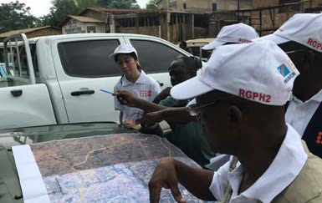
© UNFPA / Sabrina Juran

Prepared by Population and Development Staff at Headquarters and in Regional Offices.

